Task on Load Balancers
- Configure Classic Load balancer.
Steps:
Launch EC2 Instances
Go to AWS ConsoleOpen EC2Click Launch InstanceCreate 2 Instances
Example:
- Instance Name → classiclb1-ec2
- Instance Name → classiclb2-ec2
- AMI → Amazon Linux
- Instance Type → t3.micro
- Security Group → Allow
  - HTTP (80)
  - SSH (22)
Launch both.
- Install Web Server
SSH into both instances.
sudo yum update -y
sudo yum install httpd -y
sudo systemctl start httpd
sudo systemctl enable httpd
Create different pages to test load balancing.
Server 1
echo "Server 1" | sudo tee /var/www/html/index.html
Server 2
echo "Server 2" | sudo tee /var/www/html/index.html
- Create Classic Load Balancer
Go to:
EC2 → Load Balancers → Create Load Balancer
Select
Classic Load Balancer
Configure
Name: classic-loadbalancer
Scheme : Internet Facing
Listener HTTP Port 80
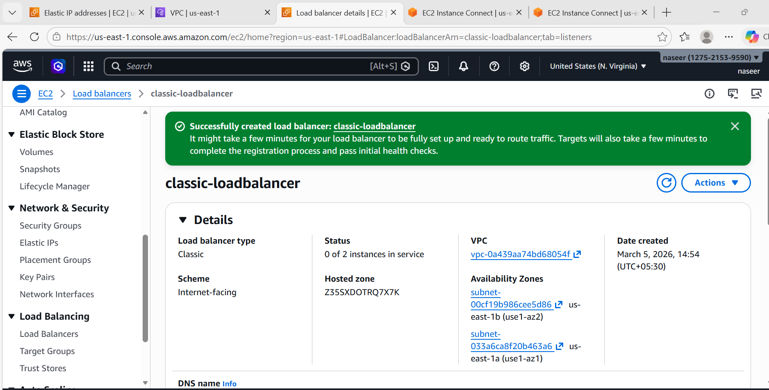
- Select VPC & Subnets
Choose Default VPC and Select 2 Availability Zones
Example: us-east-1a and us-east-1b
Configure Health Check
Ping Protocol : HTTP
Ping Port : 80
Ping Path : /
- Register Instances (classiclb1-ec2 and classiclb2-ec2)
Add to Load Balancer.
- Test Load Balancer
Copy DNS name
Example : classic-loadbalancer-1887010750.us-east-1.elb.amazonaws.com
Open browser.
Refresh multiple times.
You will see
Server 1
Server 2
Server 1
Server 2
Load balancing working
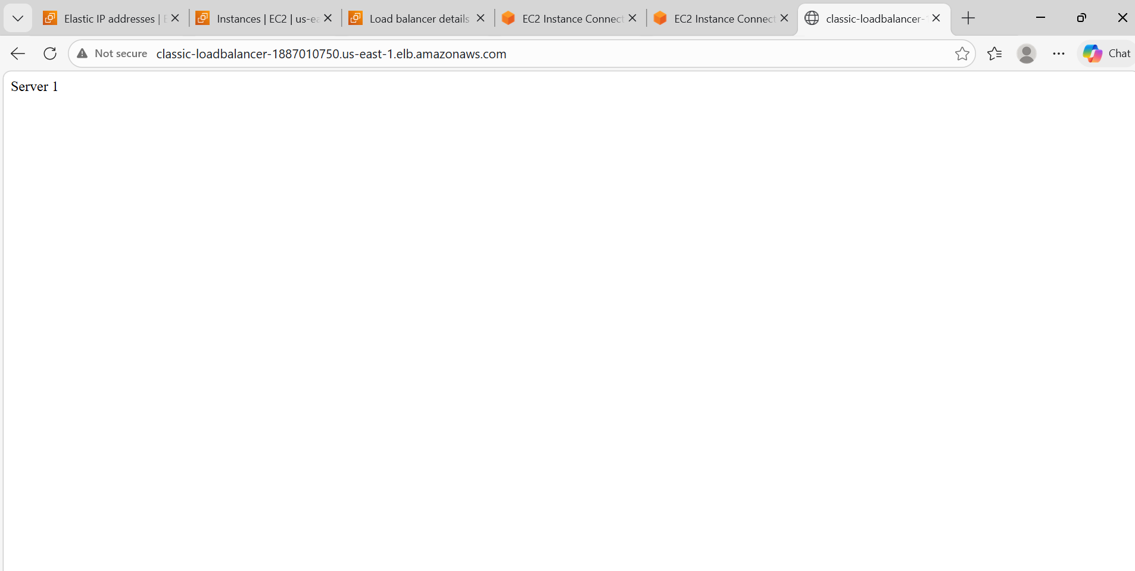
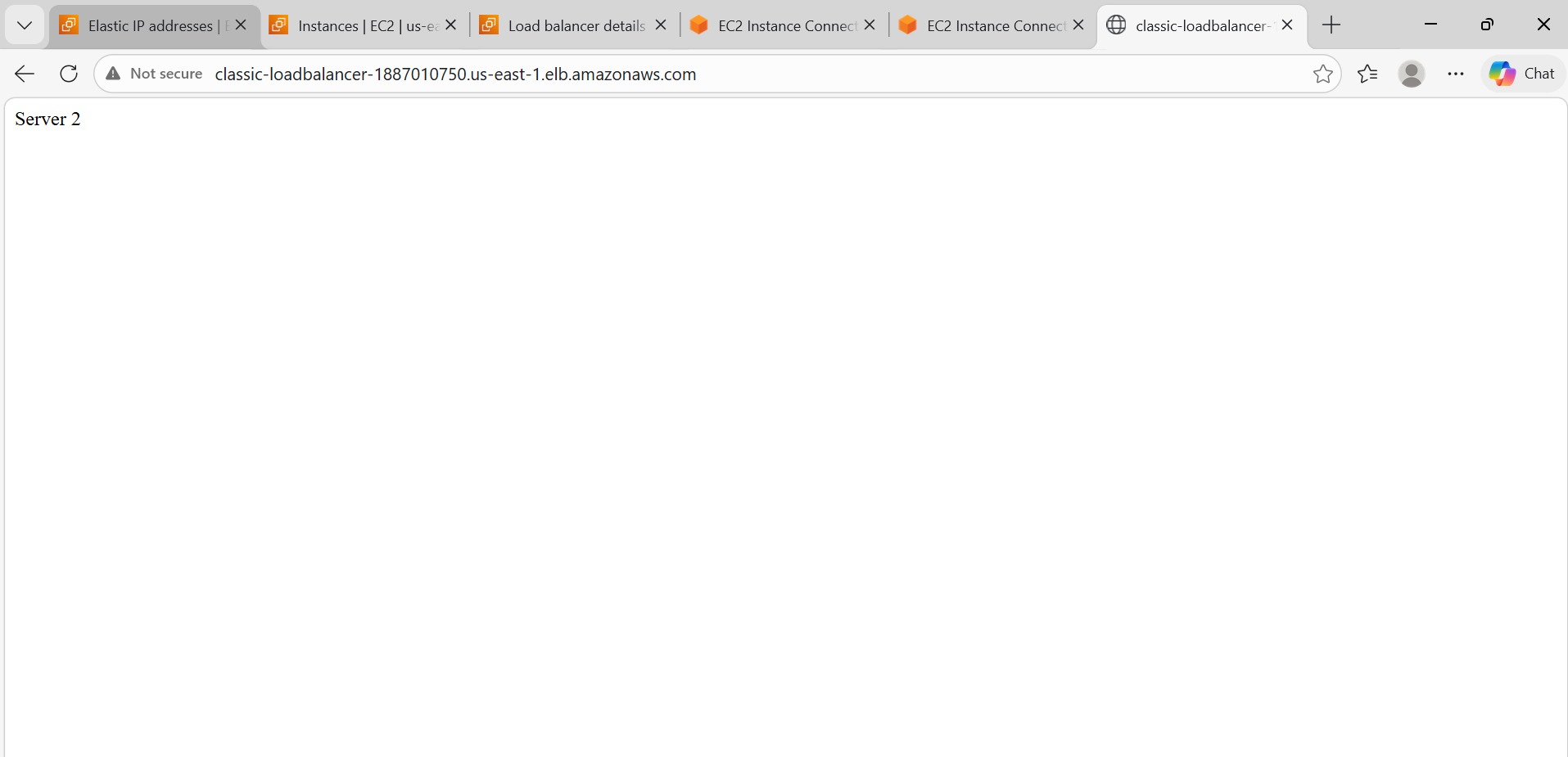
- Configure Application Load balancer.
Steps:
- Create Target Group
Go to EC2 → Target GroupsCreateTypeInstances
Name: appl-tg
Protocol HTTP
Port 80
Register Web-Server-1 Web-Server-2 Create.
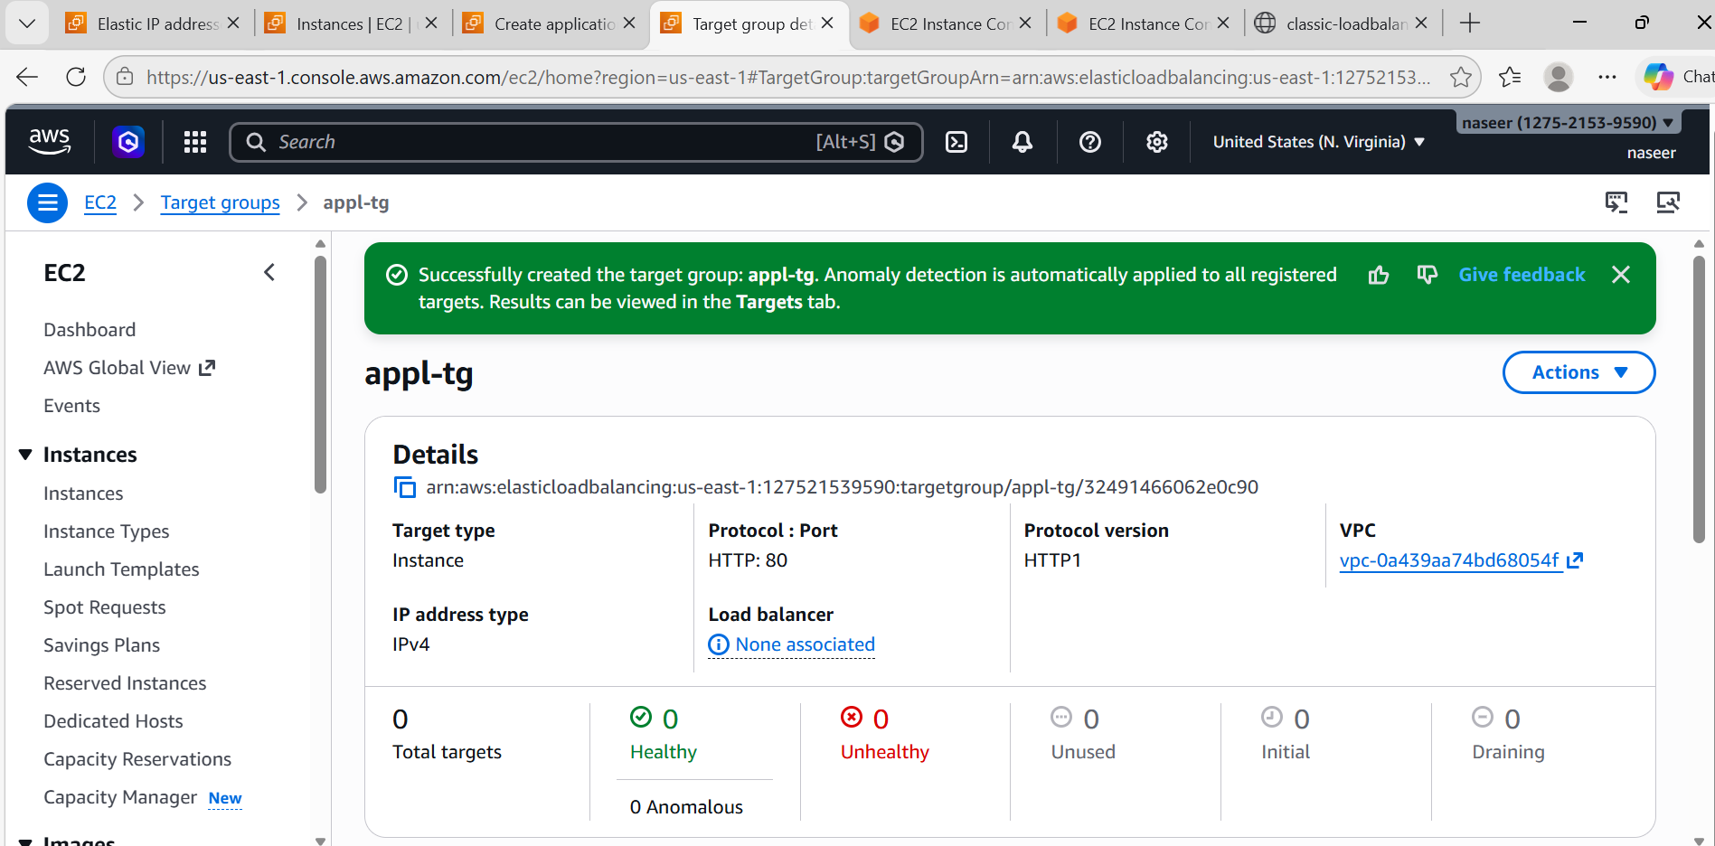
- Create Application Load Balancer
Go to EC2 → Load Balancers → Create
Select Application Load Balancer
Configure
Name application-loadbalancer
Scheme Internet Facing
IP IPv4
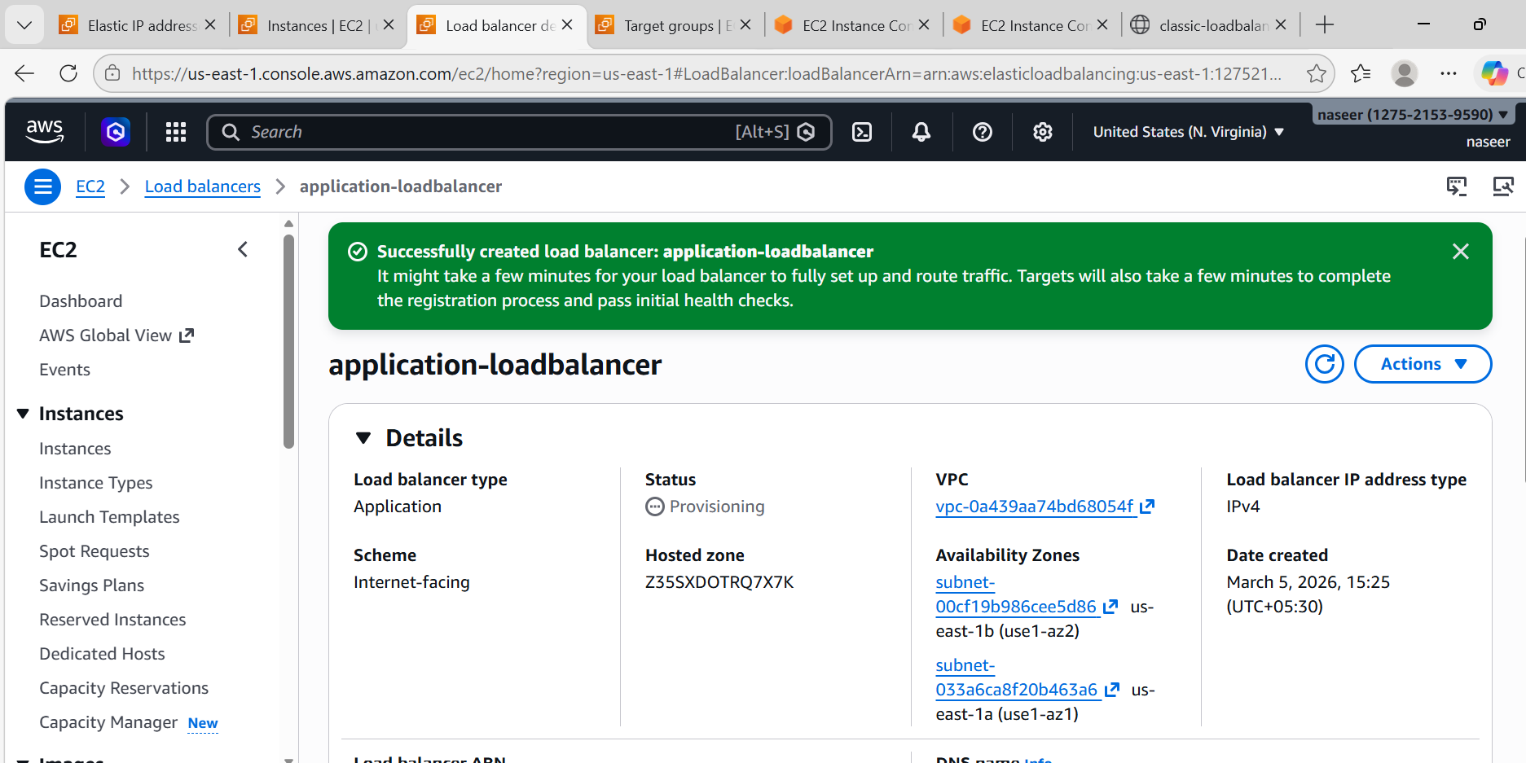

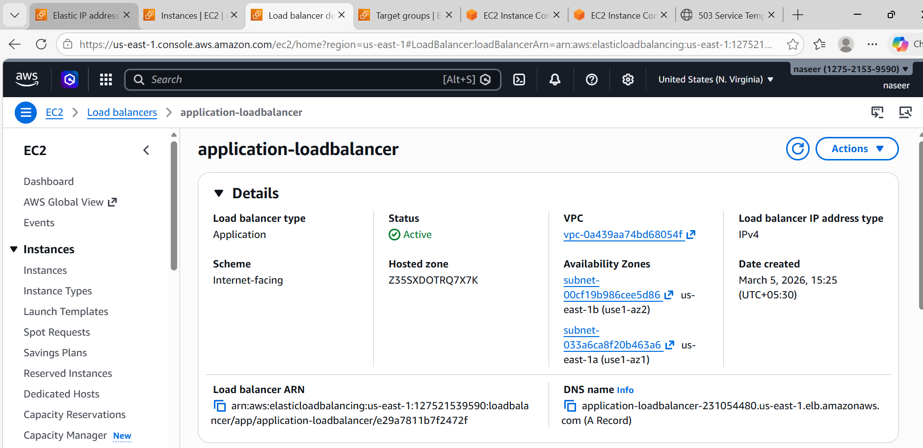
- Select Network
Choose Default VPC and 2 Subnets
Example us-east-1a, us-east-1b
- Security Group Allow HTTP 80 HTTPS 443
- Listener HTTP : 80
Forward to Target Group
Select appl-tg and Create.
- Test
Copy DNS of application-loadbalancer
Example: application-loadbalancer-231054480.us-east-1.elb.amazonaws.com
Open browser.
Refresh → traffic will rotate between servers.

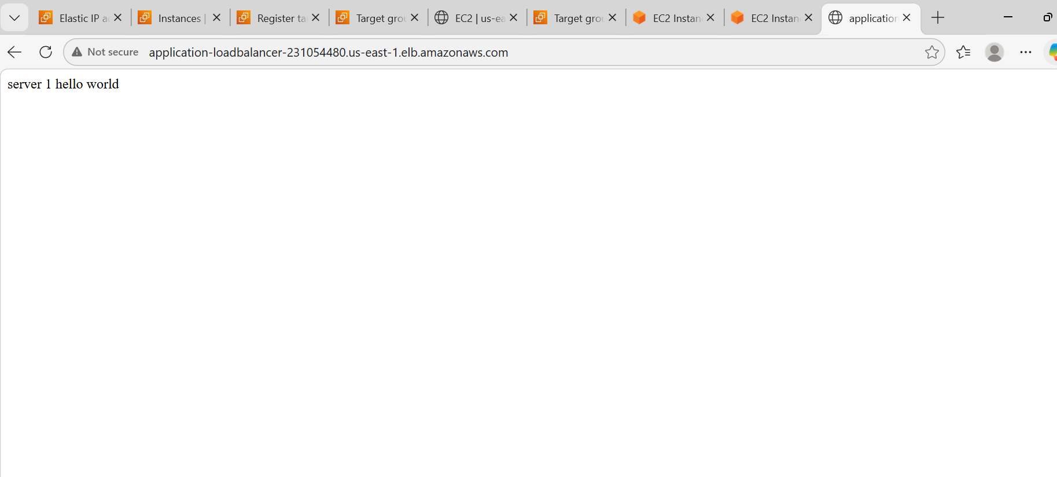
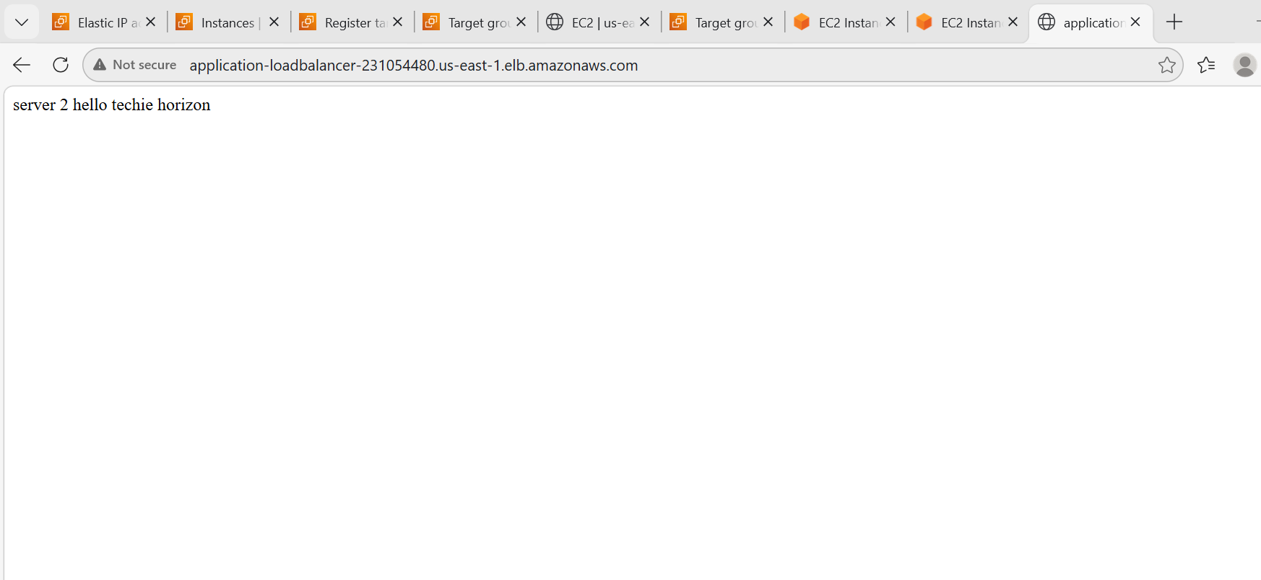
- Configure Network Load balancer.
Steps:
Create Target Group
Type Instance
Protocol TCP
Port 80
Register Web-Server-1 Web-Server-2
Create.

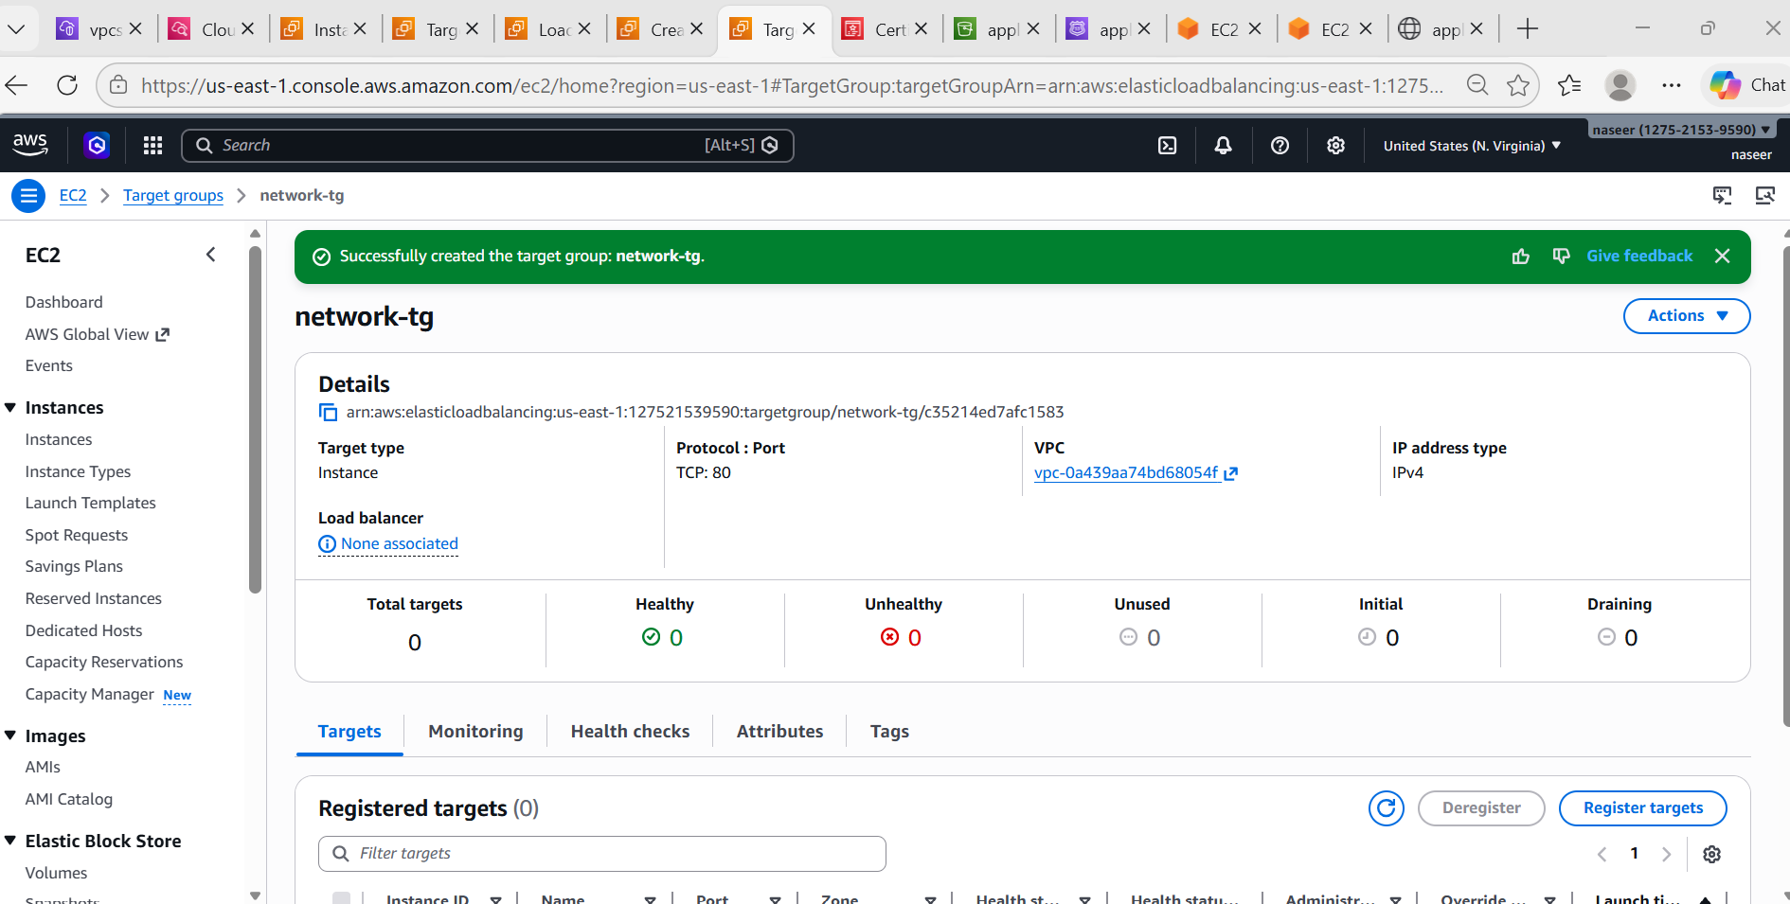
Go to EC2 → Load Balancer → Create
Network Load Balancer
Configuration
Name : network-loadbalancer
Scheme Internet Facing
Listener TCP : 80
Choose Default VPC and 2 Subnets

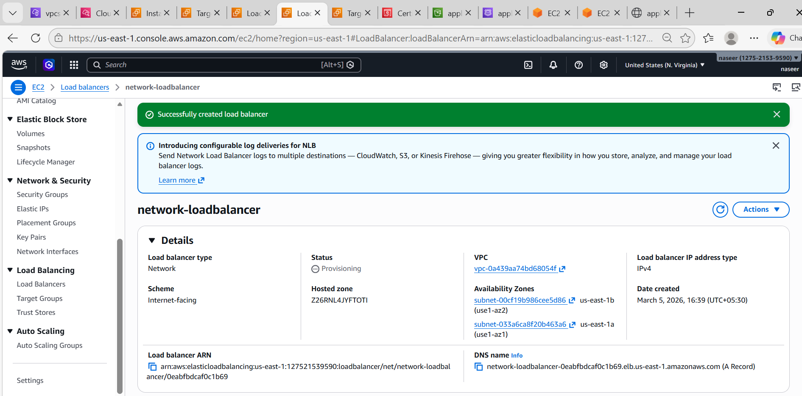
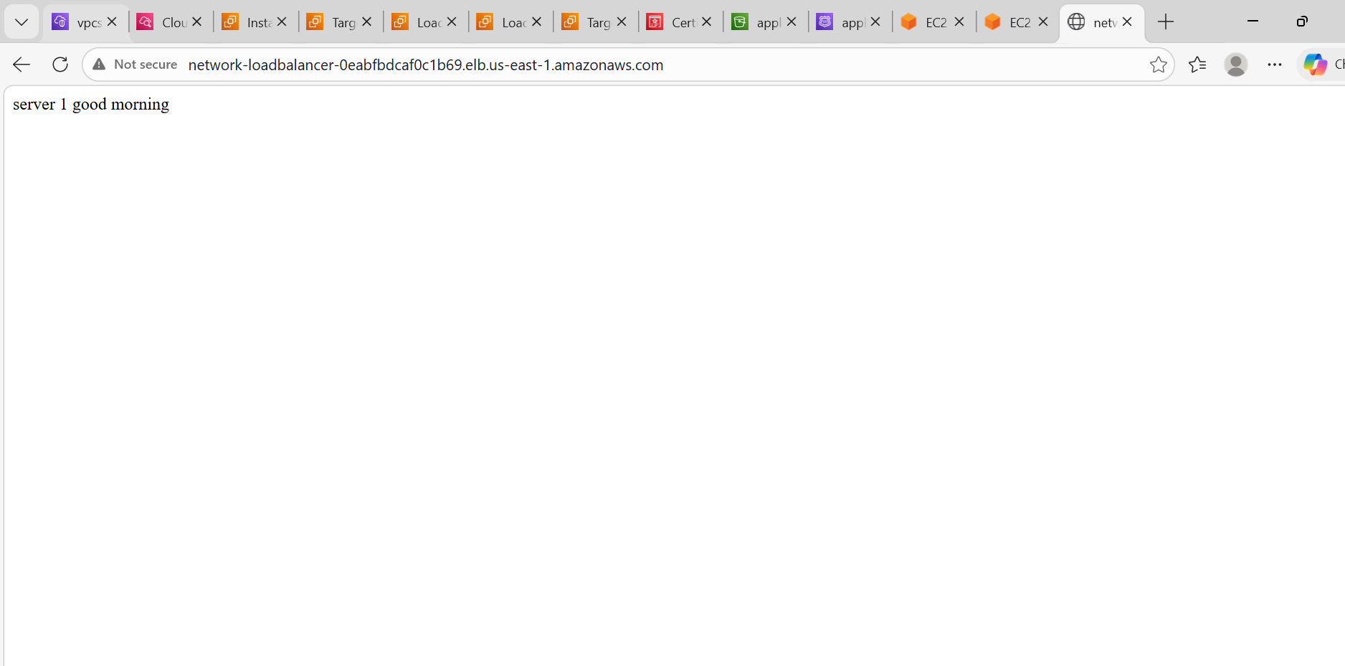
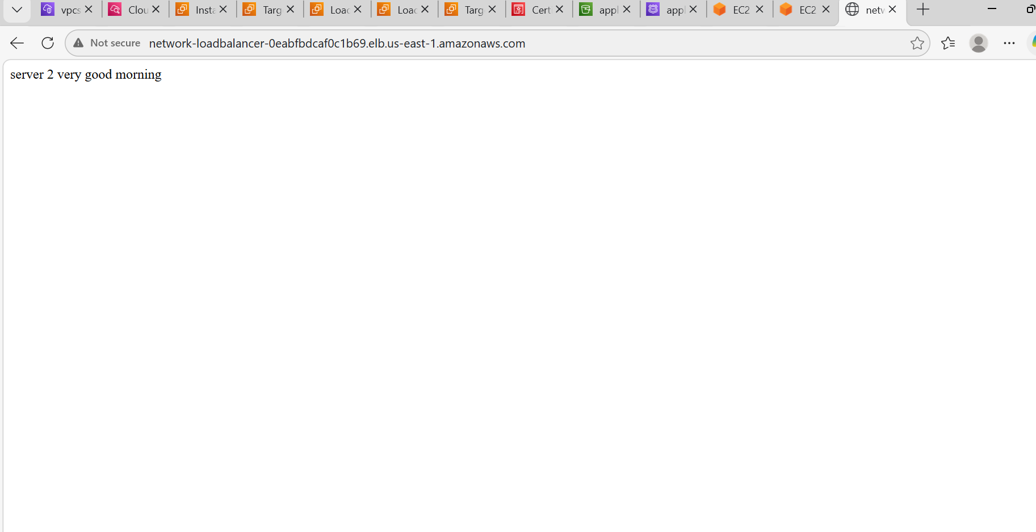
- Attach SSL for application load balancer.
SSL is handled using ACM.
Steps:
- Request Certificate
Go to AWS Certificate Manager (ACM) and Click on Request Certificate
Enter domain
Example: exampl.com and www.example.com
Validation: DNS Validation
- Validate Domain
Add DNS record in Route53.
Wait until
Status = Issued
- Attach to application-loadbalancer
Go to EC2 → Load Balancers, Select application-loadbalancer
Edit Listener
Add
HTTPS : 443
Choose
ACM Certificate
Forward to Target Group
Now HTTPS works
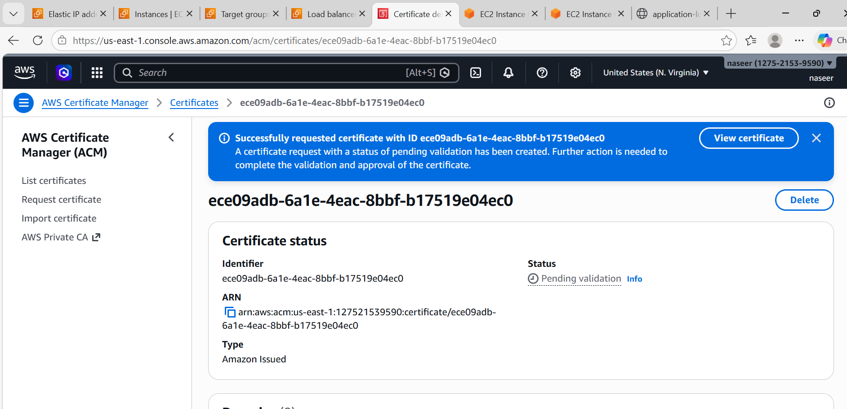
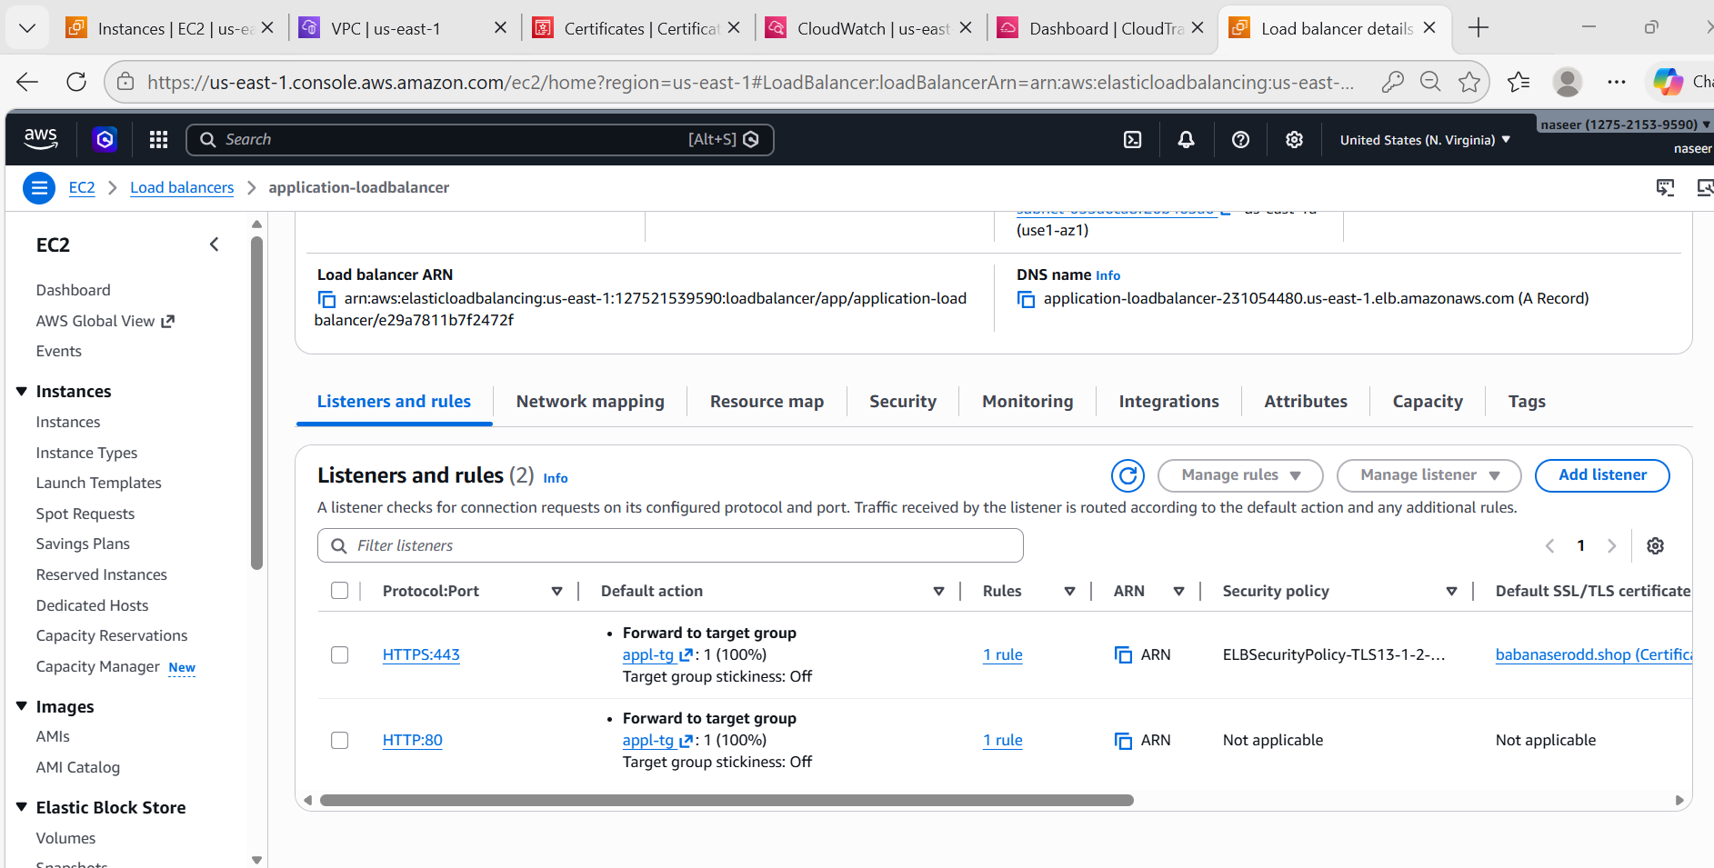
- Map Application load balancer to R53.
Steps:
Go to Route53
Create Hosted Zone.
Example: example.com and Create Record
Click Create Record
Type
A Record
Alias
Yes
Alias Target
Select
Application Load Balancer
Example
ALB-Web
Save.
Now domain works.
Example
https://example.com

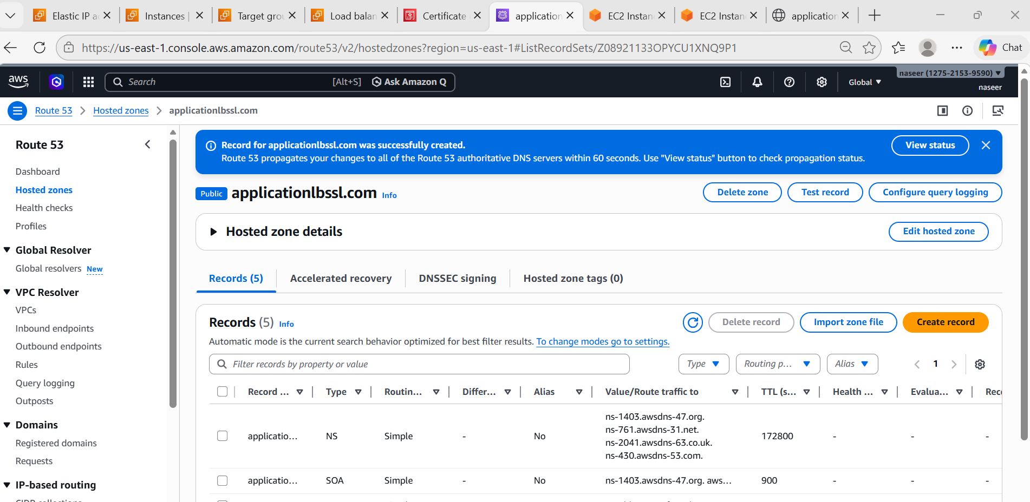
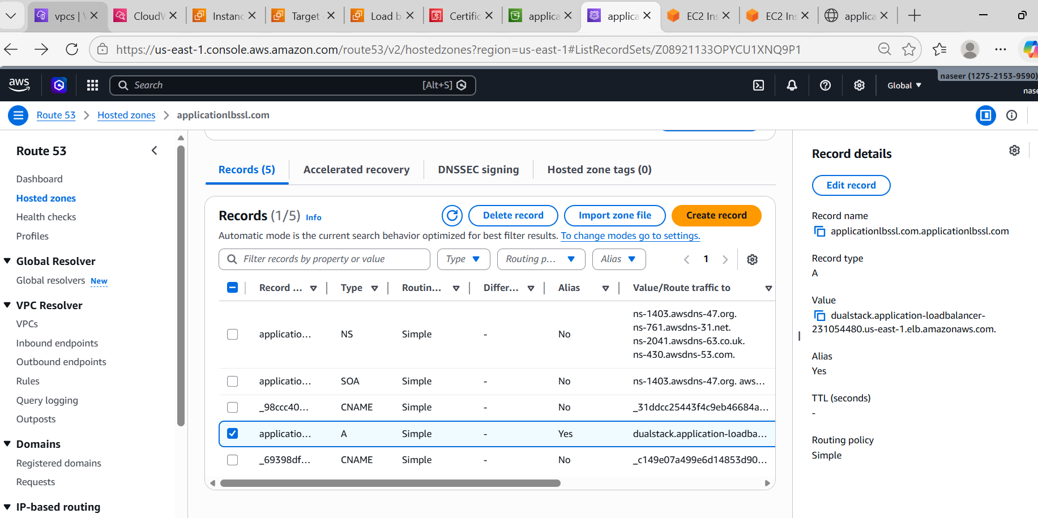
- Push the application load balancer logs to S3.
Steps:
- Create S3 Bucket
Go to S3 → Create Bucket
Name: applicationlg-bucket
Disable
Block Public Access
Create.
Enable Access Logs
Go to EC2 → Load Balancer → application-loadbalancer
Select
Attributes
Edit
Enable
Access Logs
Select bucket: applicationlg-bucket
Save.

{
"Version": "2012-10-17",
"Statement": [
{
"Sid": "AWSLoadBalancerLogsPolicy",
"Effect": "Allow",
"Principal": {
"Service": "logdelivery.elasticloadbalancing.amazonaws.com"
},
"Action": "s3:PutObject",
"Resource": "arn:aws:s3::: applicationlg-bucket /AWSLogs/*"
}
]
}

- Check Logs
Go to S3 → applicationlg-bucket
You will see
AWSLogs/
account-id/
elasticloadbalancing/
Logs stored successfully

